**Exercise 1**:

select 2x2 subsection from the "bottom left" of matrix mm

**Solution**: mm[c(3,4),c(1,2)]

**Output Screenshot:**

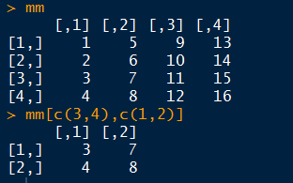

**Exercise 2**:

Obtain this data view from "df"

**Expected Output:**

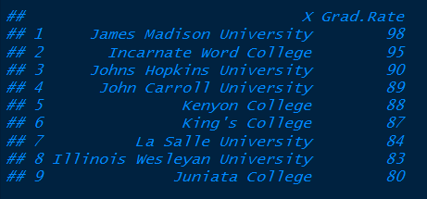

**Solution:**

df1 <- select(df, X, Grad.Rate)

head(arrange(df1, desc(Grad.Rate)),9)

**Output Screenshot:**

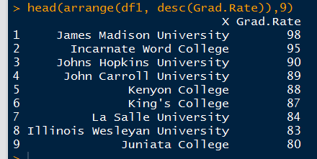

**Exercise 3:**

Find max and min tuition ("Outstate") grouped by private/public school, in dataset 'df' and 'college'

**Expected Output:**

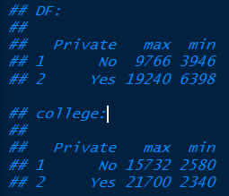

**Solution**:

df1 <- group_by(df, Private)

summarise(df1, max = max(Outstate), min = min(Outstate))

college1 <- group_by(college, Private)

summarise(college1, max = max(Outstate), min = min(Outstate))

**Output Screenshot:**

